|  |
| --- |
| **PUBLIC TRANSPORT OPTIMIZATION** |
| **Using IoT** |
| **Summitted by** |
| **Shaik Waseem**  **Skw5764@gmail .com**  **au723921106020** |
|  |
|  |
|  |
|  |

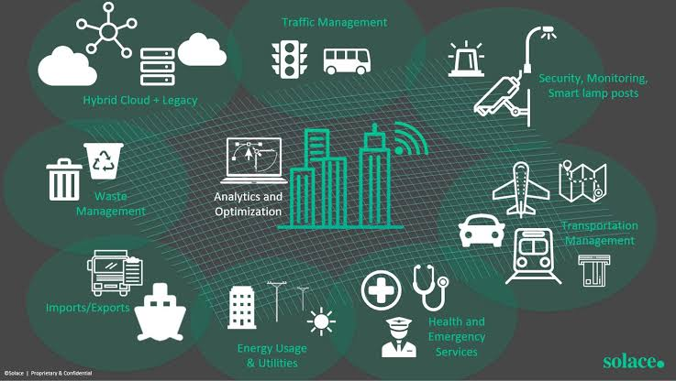

PUBLIC TRANSPORT OPTIMIZATION

INNOVATION

Public transport optimization can benefit from several innovative approaches and technologies:

* **Real-time Data and Predictive Analytics:** Utilize real-time data from GPS, sensors, and passengers' mobile devices to predict demand and optimize routes. Predictive analytics can help adjust schedules and routes dynamically.
* **Smart Ticketing and Contactless Payments**: Implement smart ticketing systems that allow passengers to pay with contactless methods, reducing boarding times and enhancing the overall experience.
* **Electric and Autonomous Vehicles**: Integrate electric or hybrid buses and experiment with autonomous vehicles to reduce emissions and improve efficiency.
* **Ride-Sharing Integration**: Collaborate with ride-sharing services to provide first-mile and last-mile connections to public transport, creating a seamless and convenient travel experience.
* **Mobility as a Service (MaaS)**: Develop MaaS platforms that allow passengers to plan and pay for multi-modal journeys with a single app, making it easier for people to use public transport.
* **Dynamic Pricing Models:** Implement dynamic pricing to encourage off-peak travel and balance demand across different times of the day.

**•Environmental Initiatives:** Invest in eco-friendly practices like solar-powered stations, green infrastructure, and energy-efficient vehicles to reduce the carbon footprint of public transport.

* **IoT and Sensors**: Use IoT devices and sensors to monitor infrastructure, vehicle health, and passenger behavior, allowing for better maintenance and resource allocation.
* **AI for Traffic Management**: Utilize AI and machine learning to optimize traffic flow, signal timing, and congestion management, reducing travel times and improving reliability.
* **Crowdsourcing Feedback:** Encourage passengers to provide feedback and suggestions through apps or surveys, allowing for continuous improvement and adaptation to changing needs.
* **Accessibility Enhancements:** Implement innovations like low-floor buses, ramps, and digital signage to improve accessibility for all passengers, including those with disabilities.
* **Green Corridors:** Create dedicated bus lanes or corridors to prioritize public transport, reducing congestion and improving speed and reliability.
* **Community Engagemen**t: Involve the community in decision-making and planning, taking into account their unique needs and preferences.

